JA043R Series Cross Flow Fan

FEATURES

160mm (6.3in) to 366mm (14.4in) lengths. AC shaded type motor, temperature resistant aluminum alloy, ball or sleeve bearings.Maximum Pressure: 1.7mmAq (0.066inH2O) to 2.6mmAq (0.10inH2O), Maximum Air Flow: 21CFM (0.6m³/min) to 70CFM (2.0m³/min) CE, UL, TUV listed.

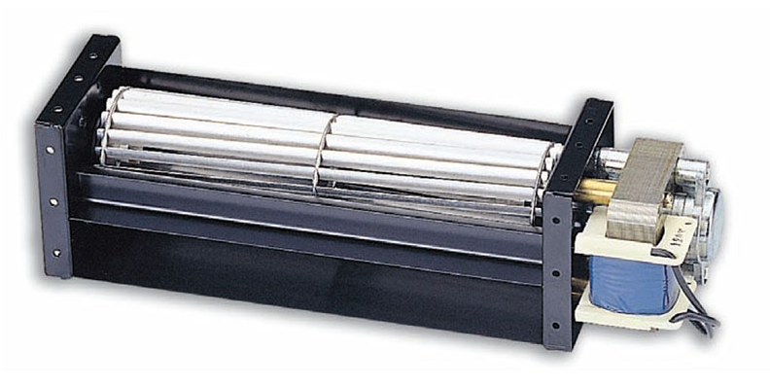

DIMINSIONS (size:mm)
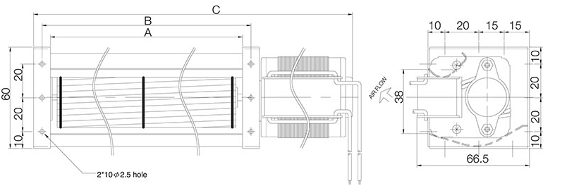
Dimensions and Specifications are subject to change without notice,
please refer to the actual product.

SPECIFICATIONS

Spec  Model | Size(mm) |  |  | Rated  Voltage  V | Rated  Frequency  Hz | Rated  Current  A | Input  Power  W | Speed  r.p.m | Max  Pressure  mmAq | Maximun  Air Flow  m³/min | CFM | Noise  dBA | Safety Approval |  |  | Weight  g
Spec  Model | A | B | C |  |  |  |  |  |  |  |  |  | UL | TUV | CE | Weight  g
JE-04309A12 | 98 | 108 | 160 | 120 | 50/60 | 0.14/0.12 | 10/9 | 2600/3000 | 1.1/1.6 | 0.7/0.8 | 25/28 | 33/35 |  |  | O | 520g
JA04309R23 | 98 | 108 | 160 | 230 | 50/60 | 0.08/0.07 | 10/9 | 2600/3000 | 1.1/1.6 | 0.7/0.8 | 25/28 | 33/35 |  |  | O | 520g
JA04315R12 | 160 | 170 | 222 | 120 | 50/60 | 0.15/0.13 | 11/10 | 2300/2200 | 0.9/1.2 | 1.2/1.2 | 42/42 | 35/35 |  |  | O | 550g
JA04315R23 | 160 | 170 | 222 | 230 | 50/60 | 0.08/0.07 | 11/10 | 2500/2500 | 0.9/1.2 | 1.2/1.2 | 42/42 | 35/35 |  |  | O | 550g
JA04319R12 | 198 | 208 | 264 | 120 | 50/60 | 0.22/0.19 | 15/14 | 2400/2500 | 0.9/1.2 | 1.5/1.6 | 53/56 | 32/35 |  |  | O | 650g
JA04319R23 | 198 | 208 | 264 | 230 | 50/60 | 0.09/0.08 | 13/12 | 2400/2500 | 0.9/1.2 | 1.5/1.6 | 53/56 | 32/35 |  |  | O | 650g
JA04324R12 | 250 | 260 | 315 | 120 | 50/60 | 0.22/0.20 | 16/15 | 2400/2300 | 0.9/1.0 | 1.9/1.8 | 67/70 | 34/33 | O |  | O | 680g
JA04324R23 | 250 | 260 | 315 | 230 | 50/60 | 0.09/0.08 | 13/12 | 2300/2000 | 0.9/1.0 | 1.8/1.6 | 63/56 | 33/30 |  |  | O | 680g
JA04329R12 | 300 | 310 | 375 | 120 | 50/60 | 0.32/0.29 | 22/21 | 2600/2900 | 1.2/1.4 | 2.5/2.7 | 88/95 | 38/40 | O |  | O | 890g
JA04329R23 | 300 | 310 | 375 | 230 | 50/60 | 0.14/0.13 | 19/18 | 2500/2500 | 1.2/1.4 | 2.5/2.5 | 88/88 | 37/37 | O |  | O | 890g
JA04335R12 | 360 | 370 | 435 | 120 | 50/60 | 0.34/0.32 | 23/23 | 2500/2500 | 1.2/1.3 | 3.3/3.3 | 117/117 | 38/38 | O |  | O | 920g
JA04335R23 | 360 | 370 | 435 | 230 | 50/60 | 0.15/0.14 | 20/19 | 2400/2100 | 1.2/1.3 | 3.2/2.5 | 113/88 | 36/33 | O |  | O | 920g

